**HARDWARE COMPONENTS**

Top of Form

Bottom of Form

## ****Introduction****

Computer hardware refers to the physical components of a computer that can be seen and touched. Examples include the **Monitor, Central Processing Unit (CPU), Mouse, Joystick**, etc. These components allow users to control computer operations such as input and output.

## ****Computer Hardware Parts****

Computer hardware components are classified into four categories:

1. **Input Devices**
2. **Output Devices**
3. **Storage Devices**
4. **Internal Components**

## ****1. Input Devices****

Input devices allow users to interact with the computer by entering data and commands. These devices convert information into a format that the computer can process.

### ****Common Input Devices:****

* **Keyboard**:
  + The most common input device used to enter data.
  + Typically consists of **104 keys** (numeric, alphabet, and function keys).
  + Can be connected via **cable** or **Bluetooth**.
* **Mouse**:
  + A pointing device used to control the cursor on the screen.
  + Features **left, middle, and right buttons** for selection and operations.
  + Includes a **sensor** to track movement speed.
* **Scanner**:
  + Converts images and documents into digital format, similar to a Xerox machine.
* **Trackball**:
  + Functions like an upside-down mouse.
  + Requires less space as the user moves the ball rather than the device itself.
* **Light Pen**:
  + A light-sensitive device used on CRT screens for drawing and selecting objects.
* **Microphone**:
  + Records sound and converts it into electrical signals for processing.
* **Optical Character Reader (OCR)**:
  + Detects **alphanumeric characters** using a light source and photocells.
* **Bar Code Reader**:
  + Reads barcodes and converts them into electrical signals for computer processing.

## ****2. Output Devices****

Output devices display the results of computer operations in a human-readable format.

### ****Common Output Devices:****

* **Monitor**:
  + Also known as **Visual Display Unit (VDU)**.
  + Displays text, images, and videos from the computer.
* **Printer**:
  + Converts digital data into printed format on paper.
  + Types:
    - **Laser Printer**
    - **Dot-Matrix Printer**
    - **Inkjet Printer**
* **Plotter**:
  + Similar to a printer but used for large drawings, architectural blueprints, and high-quality images.
* **Speakers**:
  + Used for audio output, such as music or sound effects.

## ****3. Storage Devices****

Storage devices hold data permanently or temporarily.

### ****Types of Storage Devices:****

### ****1. CD (Compact Disc)****

* Circular in shape, made of plastic and polycarbonate material.
* **Storage capacity:** **600 MB – 700 MB**.
* **Types of CDs:**
  + **CD-ROM** (Read-Only Memory) – Cannot be erased or rewritten.
  + **CD-R** (Recordable) – Can be written once and read multiple times.
  + **CD-RW** (Rewritable) – Can be erased and rewritten multiple times.

### ****2. DVD (Digital Video/Versatile Disc)****

* Similar to CDs but with **higher storage capacity**.
* **Types of DVDs:**
  + **DVD-ROM** – Read-only, used for applications and databases.
  + **DVD-R / DVD+R** – Write once, read multiple times.
  + **DVD-RW / DVD+RW** – Rewritable up to **1,000 times**.
  + **DVD-RAM** – Provides **high security** and allows up to **100,000 rewrites**.

### ****3. Hard Disk****

* **Non-volatile storage device** that stores data magnetically.
* **Types of Hard Disks:**
  + **Internal Hard Disk** – Permanently installed in a computer with large storage.
  + **Internal Cartridges** – Removable storage alternative to an internal hard disk.
  + **Hard Disk Packs** – Used in **banks and government sectors** for large-scale data storage (in petabytes).

## ****4. Internal Components****

These are the essential components inside a computer system.

### ****1. CPU (Central Processing Unit)****

* Known as the **heart of the computer**.
* Consists of three units:
  1. **Control Unit (CU)** – Directs operations.
  2. **Arithmetic Logic Unit (ALU)** – Performs calculations and logical operations.
  3. **Memory Unit** – Stores processed data before output.

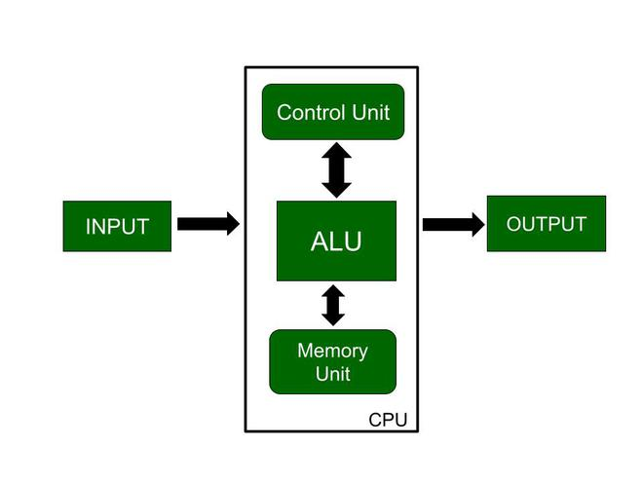

### ****2. Motherboard****

* The **main circuit board** that connects all computer components.
* Contains **RAM slots, controllers, chipsets**, etc.

### ****3. RAM (Random Access Memory)****

* Temporary (volatile) memory that holds active programs and data.
* **Types of RAM:**
  + **SRAM (Static RAM)** – Faster, expensive, and used for cache memory.
  + **DRAM (Dynamic RAM)** – Slower, cheaper, and used as main memory.

### ****4. Video Graphics Array (VGA) Port****

* Used for connecting monitors to a computer.
* Troubleshooting includes checking for loose cables, dust, or damage.

### ****5. Power Supply****

* Provides power to all components.
* Diagnosed by testing different cords or sockets.

### ****6. Cooling Fan****

* Prevents overheating, especially during high-intensity tasks like gaming.
* Needs regular cleaning and replacement if damaged.

### ****7. Hard Drive****

* Stores **files, programs, and data** using magnetic-coated disks.
* A failing hard drive may indicate data corruption.

## ****Relationship Between Hardware and Software****

* **Hardware and software are interdependent.** Hardware is useless without software, and software requires hardware to function.
* **Hardware is a one-time investment, while software requires regular updates.**
* **Software development is costly, whereas hardware can only be modified or replaced.**
* **Multiple software applications can run on a single hardware device.**
* **Software serves as an interface between the user and the hardware.**

Top of Form

Bottom of Form

**Mother board**

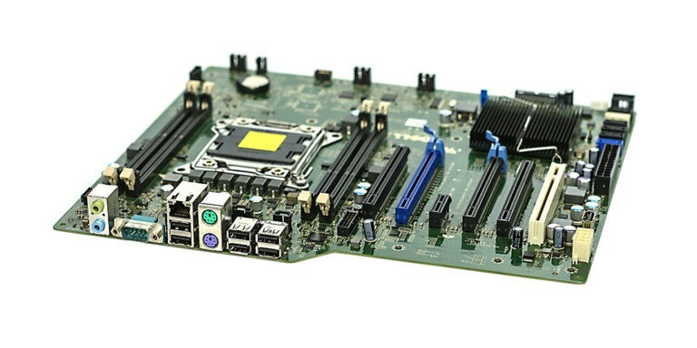

A motherboard is the central printed circuit board (PCB) in a computer that connects all the different components. It acts as the backbone of the computer, allowing various parts like the CPU, memory, storage devices, and peripherals to communicate with each other. The motherboard also provides power to these components and dictates the overall capabilities and expandability of the system.

* **Components:** A motherboard houses essential components like the CPU socket, memory slots, chipset, BIOS, expansion slots (PCIe), and connectors for storage devices (SATA, M.2) and peripherals.
* **Function:** It provides the electrical connections and pathways for data transfer between all the components, ensuring they work together seamlessly.
* **Types:** Motherboards come in various form factors (ATX, Micro-ATX, Mini-ITX) and are designed to support specific CPUs and memory types.
* **Importance:** The motherboard choice is crucial as it determines the computer's performance, upgrade potential, and compatibility with other hardware.

In essence, the motherboard is the foundation upon which a computer system is built, making it a critical component for any computer build or upgrade.

**RAM modules**

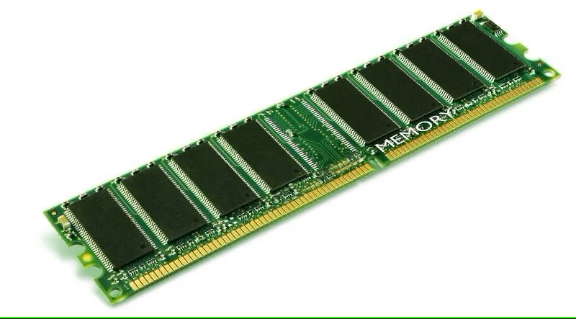

RAM modules, also known as memory modules or RAM sticks, are essential components in computers that provide temporary storage for data that the CPU actively uses.

**Function:**

* **Temporary Storage:** RAM (Random Access Memory) is a type of volatile memory, meaning it loses its data when the computer is turned off. It holds the data and instructions that the CPU needs to access quickly for current tasks.
* **Speed:** RAM allows for very fast read and write operations, enabling the CPU to process information efficiently. This speed is crucial for smooth multitasking and running demanding applications.

**Components:**

* **DRAM Chips:** RAM modules consist of a series of Dynamic Random Access Memory (DRAM) chips mounted on a printed circuit board (PCB).

These chips are where the actual storage of data occurs.

* **PCB:** The PCB provides the electrical connections between the memory chips and the motherboard, allowing the CPU to access the data.

**Types:**

* **DIMM:** Dual Inline Memory Modules are the most common type used in desktop computers.
* **SO-DIMM:** Small Outline DIMMs are smaller versions of DIMMs used in laptops and other compact devices.

**Importance:**

* **Performance:** The amount and speed of RAM significantly impact a computer's performance. More RAM allows for smoother multitasking and the ability to run more demanding applications. Faster RAM speeds up data processing, leading to better overall system responsiveness.
* **Upgrading:** Upgrading RAM is a common way to improve a computer's performance. By adding more RAM or replacing existing modules with faster ones, users can enhance their computing experience.

**In summary, RAM modules are crucial for providing fast and temporary storage for the data that the CPU needs to operate effectively. They play a vital role in determining a computer's performance and responsiveness**

**Daughter cards**

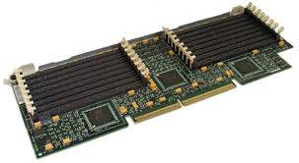

Daughter cards, also known as daughter boards, piggyback boards, or riser cards, are small circuit boards that connect directly to a computer's motherboard or another expansion card. They are used to add functionality or expand the capabilities of the main board.

**Function:**

* **Adding Functionality:** Daughter cards provide extra features that might not be present on the motherboard itself. This can include things like additional memory, specialized audio processing, or unique ports for specific tasks.
* **Expanding Capabilities:** They can increase the capacity of existing components, such as adding more RAM slots or allowing for more storage devices.

**Types:**

* **RAM DIMMs:** These are a common example of daughter cards, providing slots for additional RAM modules.
* **Storage Expansion Boards:** These cards allow for the connection of additional storage devices, such as M.2 SSDs.
* **Graphics Cards:** While often considered separate expansion cards, graphics cards can also be seen as daughter cards that enhance the system's graphics processing capabilities.
* **Network Interface Cards:** These cards add network connectivity to a computer, often providing additional Ethernet ports or Wi-Fi capabilities.
* **Audio Processing Boards:** These cards enhance the audio capabilities of a computer, providing higher-quality sound output and processing.

**Benefits:**

* **Cost-Effective Upgrades:** Daughter cards offer a cost-effective way to upgrade a computer system without having to replace the entire motherboard.
* **Versatility and Customization:** They allow for a high degree of customization, enabling users to tailor their systems to their specific needs.
* **Improved Performance:** By adding components like RAM or high-speed storage, daughter cards can significantly improve a computer's performance.

**In summary, daughter cards are a valuable tool for expanding the capabilities and customizing computer systems. They provide a flexible and cost-effective way to enhance functionality and improve performance.**

**Bus slots**

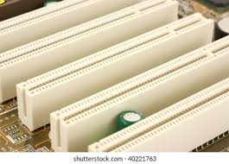

**Expansion slots (or bus slots)** are sockets on a computer's motherboard where you can install expansion cards. These cards add extra functionality to your computer, like:

* **Graphics cards:** For better video output and gaming performance.
* **Sound cards:** For higher quality audio.
* **Network cards:** To connect to a wired or wireless network.
* **Storage controllers:** To add more hard drives or SSDs.

**Key things about expansion slots:**

* **Different types:** Over time, there have been various types of slots like PCI, AGP, and most recently, **PCIe (PCI Express)**, which is the most common type today.
* **Purpose:** They allow you to upgrade or customize your computer without replacing the entire motherboard.
* **Importance:** Expansion slots make computers versatile and adaptable to different needs.

Essentially, they're like extra ports on your computer's motherboard, allowing you to plug in new "gadgets" to enhance its capabilities.

**SMPS**

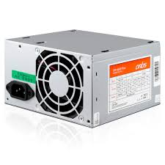

An SMPS is a type of power supply that efficiently converts electrical power. Unlike traditional linear power supplies, SMPS units use a switching regulator to transfer power, making them smaller, lighter, and more efficient.

**Key Features:**

* **Efficiency:** SMPS units are known for their high efficiency, typically ranging from 80% to 95%. This means less energy is wasted as heat, making them more environmentally friendly and cost-effective.
* **Compact Size:** Due to their design, SMPS units are smaller and lighter than linear power supplies, making them ideal for portable devices and space-constrained applications.
* **Wide Input Voltage Range:** Many SMPS units can operate with a wide range of input voltages, making them suitable for use in different countries and with varying power sources.
* **Regulation:** SMPS units provide stable and regulated output voltages, ensuring that connected devices receive a consistent power supply.

**Internal storage devices**

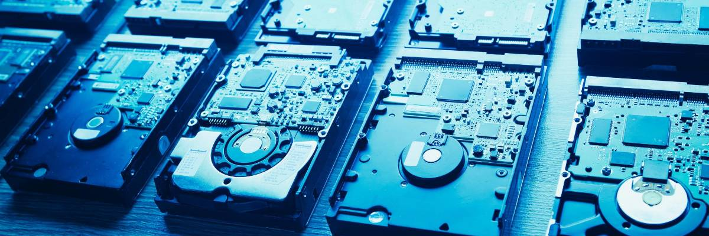

Internal storage devices are the hardware components within a computer that hold data persistently, even when the power is off. They are essential for storing the operating system, applications, user files, and other data necessary for the computer to function.

* **Hard Disk Drives (HDDs):** Traditional storage devices that use spinning platters and a read/write head to store data magnetically. They offer large storage capacities at a relatively low cost per gigabyte but are slower than newer technologies.
* **Solid State Drives (SSDs):** Use flash memory to store data, offering significantly faster read and write speeds compared to HDDs. SSDs are more durable and consume less power but are generally more expensive per gigabyte.
* **Solid State Hybrid Drives (SSHDs):** Combine the large storage capacity of an HDD with the speed of an SSD by incorporating a small amount of flash memory. They offer a compromise between speed and cost.
* **M.2 SSDs:** A form factor for SSDs that is smaller and faster than traditional SATA SSDs. They connect directly to the motherboard via an M.2 slot, often using the NVMe (Non-Volatile Memory Express) protocol for even higher performance.
* **Internal Optical Drives (CD/DVD/Blu-ray):** While less common now, these drives can read and sometimes write data to optical discs. They are used for software installation, data backup, and media playback.

**Interfacing ports**

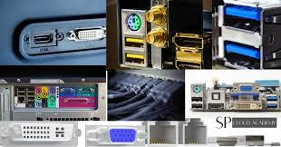

Interfacing ports are essential components on a computer that allow it to connect and communicate with external devices. These ports act as communication channels, enabling data transfer between the computer and peripherals like printers, keyboards, mice, monitors, and more.

**Function:**

* **Connection:** Interfacing ports provide a physical connection point for external devices to connect to the computer.
* **Communication:** They facilitate the exchange of data and signals between the computer and the connected devices.

**Types of Interfacing Ports:**

* **USB (Universal Serial Bus):** A versatile and widely used port for connecting various devices like keyboards, mice, external drives, and more.
* **HDMI (High-Definition Multimedia Interface):** Primarily used for connecting displays, transmitting both audio and video signals.
* **DisplayPort:** Another interface for connecting displays, offering high bandwidth and support for multiple monitors.
* **Ethernet:** Used for wired network connections, enabling communication with other computers and the internet.
* **Audio Jacks:** Ports for connecting headphones, speakers, and microphones for audio input and output.

**Importance:**

* **Connectivity:** Interfacing ports are crucial for connecting peripherals and expanding the functionality of a computer.
* **Data Transfer:** They enable the transfer of data between the computer and external devices, allowing for file sharing, printing, and other tasks.
* **Communication:** Ports facilitate communication with networks and other computers, enabling internet access and data exchange.

Interfacing ports are fundamental to how we interact with computers, enabling the connection and communication with a wide range of devices that enhance the user experience.